1. It shows the sum of profit for each Shipping mode out of thousand of raw data in table “ORDERS”

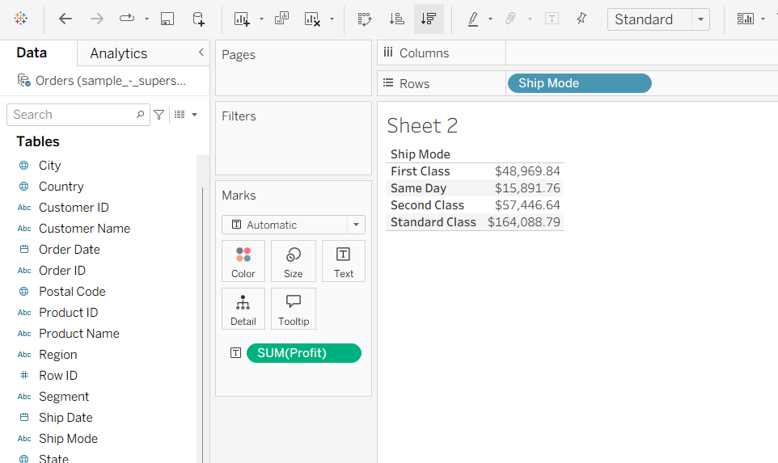

1. It shows about which types of shipping different customer segments use. *Number of Records* is added, it is grouped by dimensions, revealing the number of orders that used each *Ship Mode* for each customer *Segment*. Using your newly created table, you can explore why customers make certain shipping decisions.

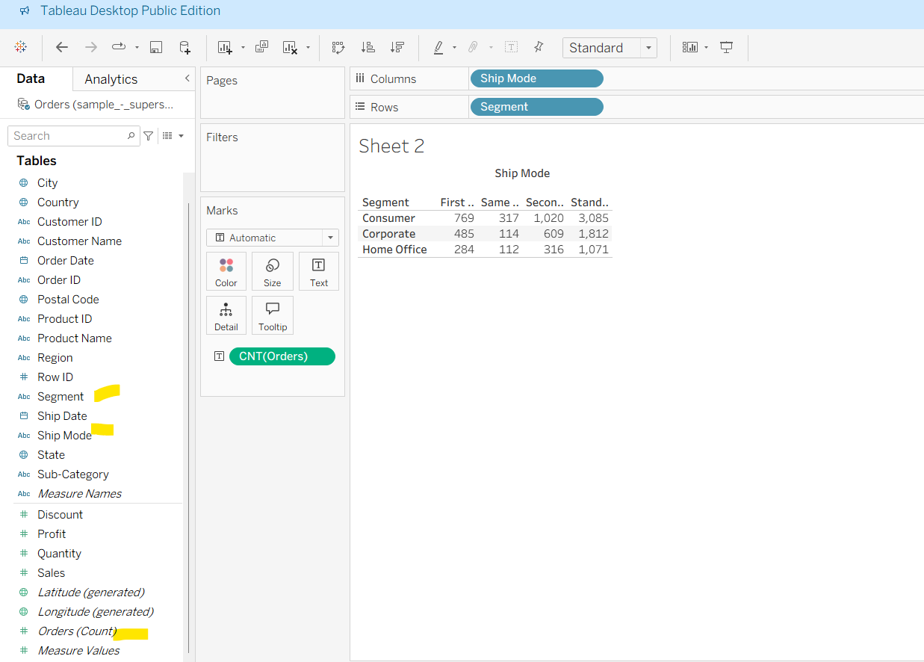

1. Below shows how we can see data segment by segment whether you place it in row or in column dimension

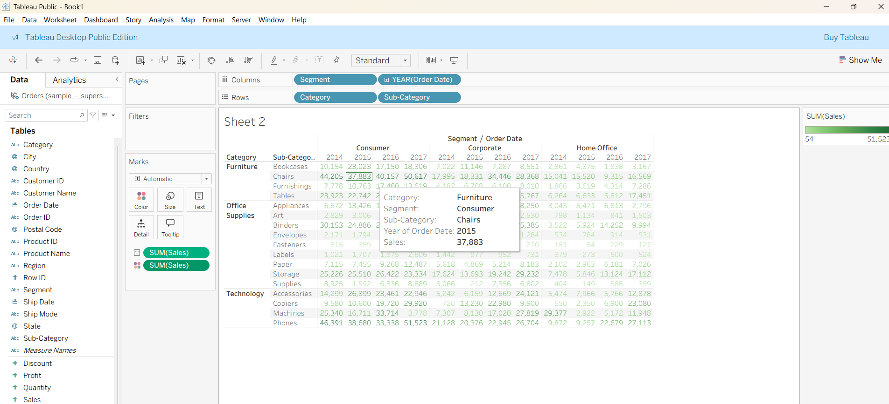

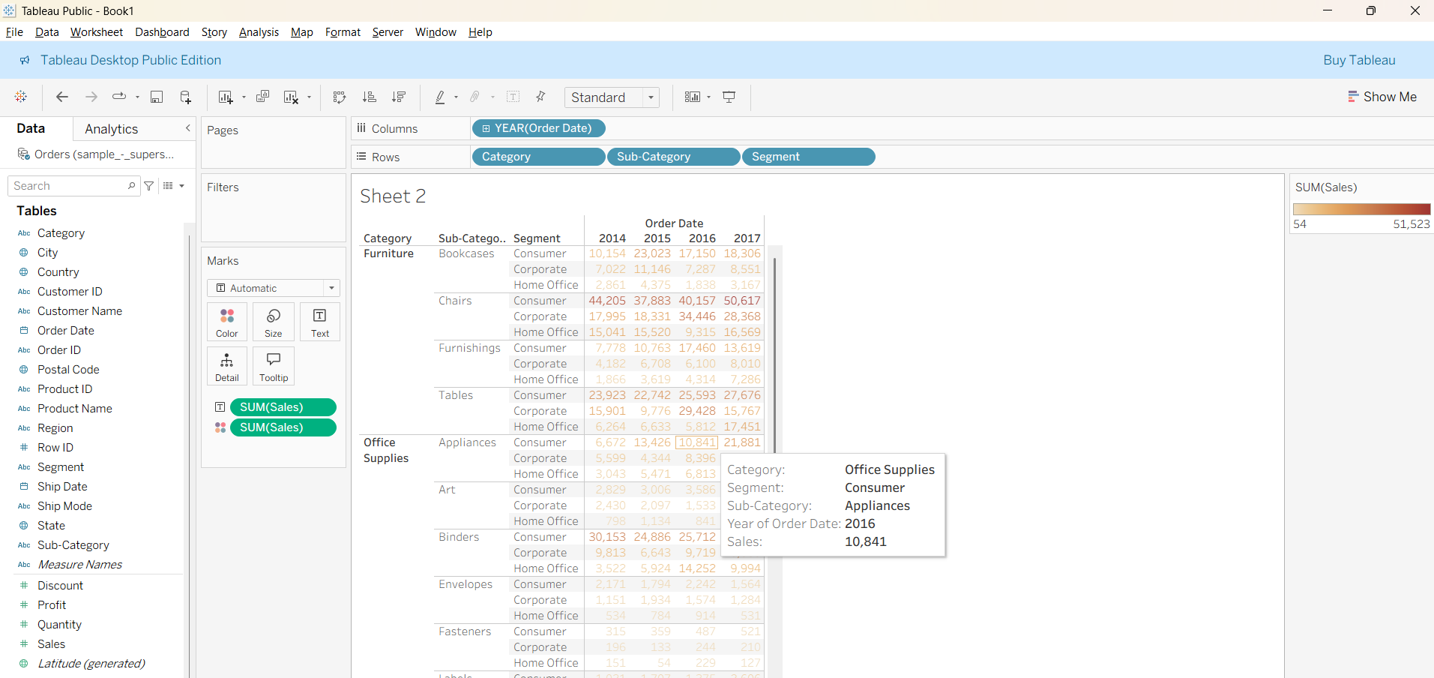

Editing the Headings

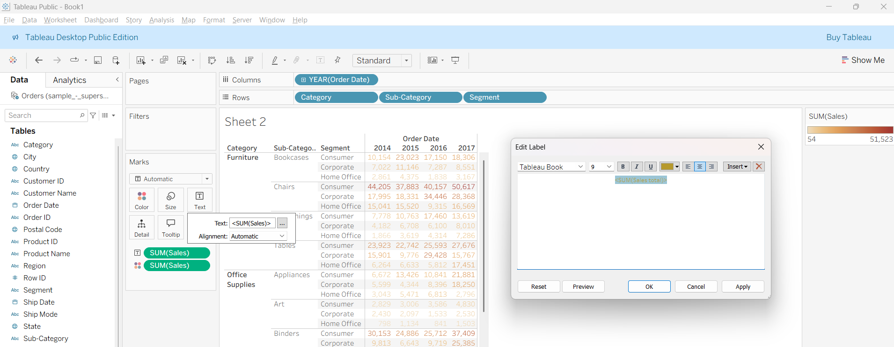

With formatting the below table looks more meaningful

